**Universal Products: Shock Absorber Eye Bushes**

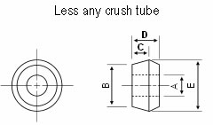**Tapered shock eye half piece**

|  |  |  |  |  |  |
| --- | --- | --- | --- | --- | --- |
| Superflex Part Ref | A (mm) | B (mm) | C (mm) | D (mm) | E (mm) |
| SF2148/12 | 12.00 | 25.00 | 12.00 | 18.00 | 30.00 |
| SF2148/15 | 15.00 | 25.00 | 12.00 | 18.00 | 30.00 |
| SF2148/16 | 16.00 | 25.00 | 12.00 | 18.00 | 30.00 |
| SF2148/19 | 19.00 | 25.00 | 12.00 | 18.00 | 30.00 |
| SF0078 | 19.00 | 31.30 | 15.00 | 20.00 | 38.00 |
| SF0065/19 | 19.00 | 40.00 | 15.00 | 25.00 | 46.00 |
| SF0065/20 | 20.00 | 40.00 | 15.00 | 25.00 | 46.00 |
| SF0065/22 | 22.00 | 40.00 | 15.00 | 25.00 | 46.00 |
| SF0065/25 | 25.00 | 40.00 | 15.00 | 25.00 | 46.00 |